

**VISUAL PERCEPTUAL SKILLS**

**&**

**MATH**

**A resource brought to you by HDSD’s Occupational Therapists**

**Visual Discrimination:** Required for learning and recognizing numbers as well as for identifying differences amongst math signs (+, x, %) and matching

**Visual Memory:** Required for recall of what math signs represent

**Spatial Relations**: Required for completing patterns, understanding patterns, accurately line up math problems, understand abstract math concepts

**Form Constancy:** Required for completing math problems written horizontally vs. vertically and generalizing math procedures outside of normal context

**Sequential Memory:** Required for memorizing math procedures, rules or formulas

**Figure Ground:** Required for finding/copying math notes off of the board and maintaining attention to pertinent information

**Visual Closure:** Required for completing math problems when only partial information is given and understanding math concepts



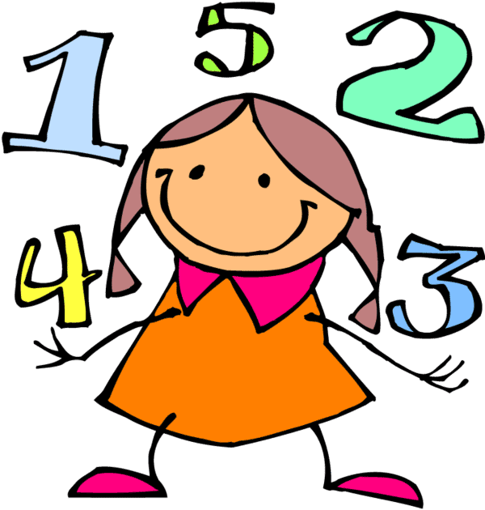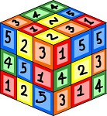

**HELPFUL VISUAL PERCEPTION TIPS TO HELP WITH MATH:**

* Clearly space words/problems on a page
* Anticipate confusions and point out examples of correct responses
* Use of window or ruler to present limited number of problems at a time
* Limit number of math problems per page
* Highlight directions or important information
* Pair math visuals with verbal descriptions/instructions
* Allow the use of a “reference” notebook complete with written out examples or video modeling to assist with recall of math formulas
* Allow use of graph paper to assist with spacing of math problems
* Provide math note taking assistance
* Color code math symbols to emphasize visual differences
* Allow checklists for math processes or use reference book to recall math steps
* Arrange seat placement in front of dry erase board during math instruction
* Present cleanly photocopied math worksheets and test forms
* Provide “helpful hints” about mistakes in order to provide a second chance to correct errors
* Encourage viewing math materials at different angles if trouble visualizing is experienced
* Present the same font/orientation on math worksheets as much as possible
* Provide text to speech option with word problems to assist with visual memory challenges

**Students with visual perceptual challenges may have difficulty with math tasks such as:**

* **Computation**
* **Number sense**
* **Counting**
* **Word problems**
* **Geometry**
* **Remembering patterns, rules, procedures or formulas**
* **Maintaining precision of math work**