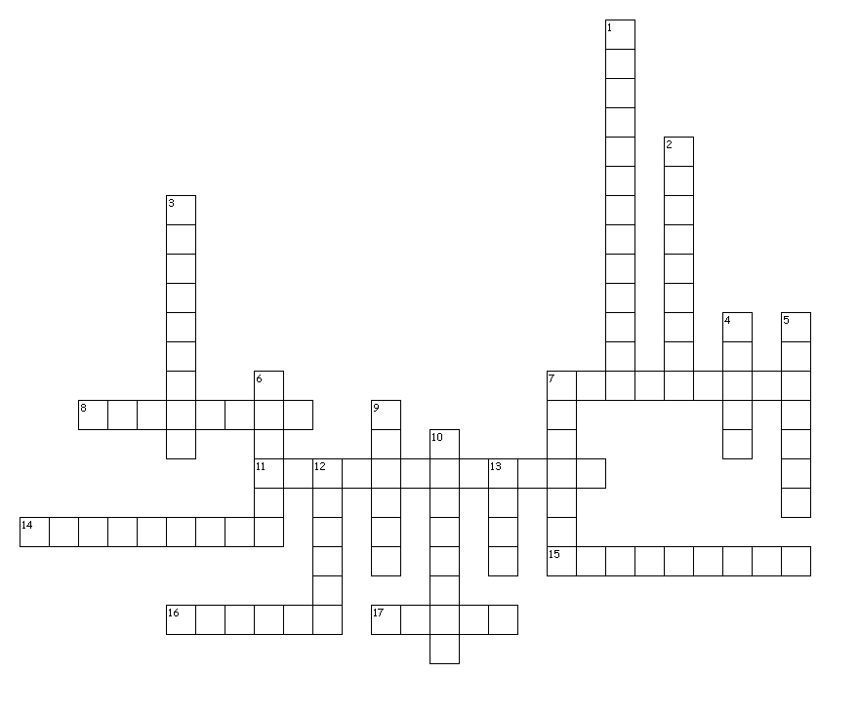**HEART/BLOOD PRESSURE**

Across

7. MOST COMMON SIGN OF HEART ATTACK

8. MAXIMUM (TOP) NUMBER IN BP

11. HIGH BLOOD PRESSURE

14. THICKNESS OF THE BLOOD

15. LOWER NUMBER IN BLOOD PRESSURE

16. POSSIBLE RISK OF HIGH BLOOD PRESSURE

17. BIGGEST AND LONGEST ARTERY IN THE HEART

Down

1. STRONGEST PART OF THE HEART

2. COMMON CAUSE OF HEART ATTACK

3. DISTANCE BETWEEN QRS COMPLEXES

4. CONTRACTION OF ATRIA IN ECG

5. PASSING OUT CAUSED BY LOW BP

6. HEALTHY DIASTOLIC NUMBER FOR BP

7. ARTERY LOCATED IN THE NECK

9. TYPE OF EXERCISE HEALTHY FOR THE HEART

10. RATE OF HR RETURNING TO RESTING HR

12. SUBSTANCE THAT BUILDS UP IN ARTERIES

13. TOO MUCH IN DIET CAN CAUSE HIGH BP