Bridges Team Members

Eliza Tasker-Smith M. Ed

*Case Manager & Special Educator*

Heather Garcia M.A

*School Psychologist*

Danielle Bond-Ishak MS, CCC/SLP

*Speech & Language Pathologist*

Jill Severino OTR/L, ATP

*Occupational Therapist*

*Assistive Technology Professional*

Dorothy O’Rourke M.Ed.

*Coordinator of Special Education*

**Individualized Curriculum**

The Bridges program focuses heavily on teaching, modeling, and providing opportunities for practice and generalization of those skills needed to communicate, regulate physically and emotionally, and become involved and productive members of the community. This encompasses learning how to actively and meaningfully engage with others, build relationships and function as group members, whether small social or work groups, larger classrooms or public community settings.

Curriculum and expectations for student competency are differentiated and modified to meet the needs of each individual student. Core curriculum is taught with an emphasis on having students generalize the information needed in a variety of settings, both in school, at home and in the community. Daily living skills are incorporated into the curriculum based on student needs, with the goal of maximizing independence.

Hillsboro-Deering Middle School Bridges Program

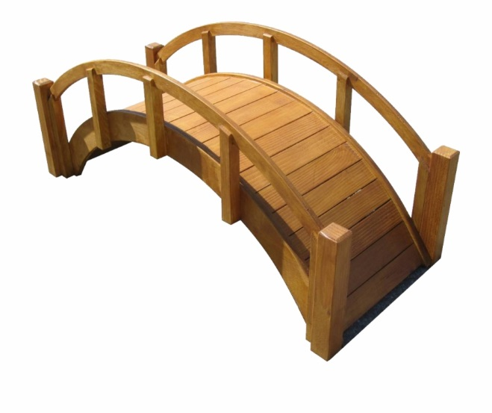

The HDMS Bridges Program’s **mission** is to ensure that students be provided with opportunities to practice and increase skills necessary to participate and engage socially in school, home, and community settings.

**Program Access**

The HDMS Bridges Program is designed to support students:

* Identified with Autism Spectrum Disorder, Intellectual & Developmental Delay, and Other Heath Impairments.
* Whose needs require individualized and/or intensive small group instruction and support.
* Whose needs require specialized staff assistance (rehabilitative assistance) to access regular classroom content and settings.
* Able to access the general education classroom in a meaningful way with specialized supports and service provided through Bridges to address social and cognitive functioning, as well as problem solving and academic support.

**Related Services**

Occupational, speech and language, physical, psychological and behavioral support and services are incorporated throughout Bridges daily programming. Related service providers and services are embedded within the Bridges program enhancing skill acquisition, practice, and use in real life settings and situations. Communication with outside providers and agencies, as well as the student’s family is encouraged to promote consistency in programming.



**Transition Services**

Student’s accessing the Bridges Program receive instruction and skills that prepare them for the transition to high school and increased personal responsibilities, including practical application of core curriculum, pre-vocational and functional daily living skills.



Hillsboro-Deering Middle School

6 Hillcat Drive

Hillsboro NH 03244

(603)464-1120