Name: __________________________________________________________ Block: ____________

NUTRITION REVIEW

1. List the 6 essential nutrients:  
 -  
 -  
 -  
 -  
 -  
 -

2. Of the nutrients listed in question 1, which contribute to caloric intake, and how many calories/gram?  
 -________________________________ : _______cal/g  
  
 -________________________________ : _______cal/g  
  
 -________________________________ : _______cal/g

3. List the 2 types of carbohydrates discussed in class:  
 -  
 -

4. Identify the type of sugar each of the following terms refers to:  
  
 -Glucose = _________________________________________________

-Fructose = ________________________________________________

-Lactose = __________________________________________________

-Sucrose = __________________________________________________

These are all examples of _______________________ sugars. (From question #3.)

5. List one example of a soluble fiber: ____________________________________  
  
 List one example of an insoluble fiber: ____________________________________

6. What is a benefit of fiber to the body?

7. What is the term for the type of fat that is a “healthy dietary fat” or “good fat”?

8. List 2 possible outcomes of having too many saturated and trans fats.

-  
 -

9. What are 2 benefits that fat have on the body? (Why do we need fats?)

-  
 -

10. How is cholesterol used in the body?

11. What is the difference between LDLs and HDLs?

12. How can someone create more “good cholesterol” in the body? What does this do to the “bad cholesterol?”

13. What are 3 functions of protein in the body?

-

-

-

14. Identify the common sources for both complete and incomplete proteins.

-Complete = _________________________________

-Incomplete = ________________________________

-What is an example of a complete protein that is made of incomplete proteins?

15. Describe the significance of the stairs being added to the food pyramid.

16. List the 5 major food groups and one food example that fits within each group.

-  
 -  
 -  
 -  
 -

17. Which vitamins are water soluble? ________ & _________

-What does water soluble mean to the consumer?

18. Which vitamins are fat soluble? ________ , _________ , _________ , & _________

-What does fat soluble mean?

19. Choose any 2 vitamins. Explain one benefit AND one food source that the vitamin is plentiful in for each chosen vitamin.

-

-

20. Define minerals and describe their role in nutrition.

21. Choose ONE mineral. Identify its function and 2 food sources in which the mineral could be obtained.

22. List 3 food safety tips.

-  
 -  
 -

23. 95% of the body’s cholesterol is manufactured by which organ?

24. Explain why calories are necessary/beneficial in terms of nutrition and for the body.

25. A diet should be low in:

-  
 -  
 -

26. What could happen in the case that someone has **too much** fat, carbohydrates, and/or protein?

27. Which mineral is needed for strong teeth and bones?

28. Choose one issue from Food, Inc. that you feel strongly enough to support one side of an argument for. Write down your topic of choice, and at least one supporting reason or idea for why you would side in that position.

29. What are 3 health risks/illnesses that could result from continuous unhealthy dietary habits?

-  
 -  
 -

30. Describe the importance of the relationship between physical fitness & nutrition.

31. A vegetarian diet consists of a diet lacking ________________ products. What nutrient do vegetarians need to ensure they are getting adequate amounts of (that are highly present in those products)?  
  
  
32. You should aim to make __________ of all your grains whole grains.  
  
33. List any single fact about nutrition that you learned this unit, that you did NOT know prior to starting the unit.

34. List one benefit of water on the body.

35. What is the average # of recommended calories per day? (Also, the number of calories that food label information is largely based on.)

36. Define nutrition.

37. Define diet.

38. List 3 factors someone would consider in calculating the number of calories needed for daily intake.

-  
 -  
 -

39. Describe a “vegan” diet.

40. Use the food label provided to answer the following questions.  
 (Hint: Keep in mind the number of calories per gram of fat, carbs, & protein.)

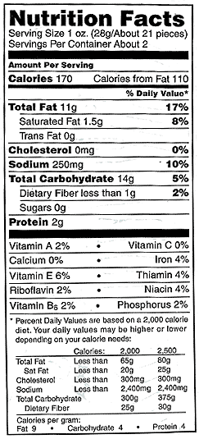A. How many calories in one serving of this product?

B. What is the serving size for this product?

C. How many calories would someone consume if they ate this whole container?

D. Which vitamin or mineral does this product contain the most of?

E. How many calories per serving come only from protein?

F. Would you consider this product to be a good source of fiber?

G. How many vitamins are listed on this food label?

H. How many minerals are listed on this food label?