**Growth & Development: Introduction**

**Puberty:**  A time of change from…

* Child-like to adult-like characteristics; physical changes occur within the body

PUBERTY IN MALES:

* Hair growth (____facial___,  
    
  ___chest___,   
    
  ___pubic__, ____body___)
* Sperm production
* Testosterone (hormone) production
* _Voice deepens______
* Shoulders broaden
* Sweat more
* Increased oil production
* __Growth Spurt______ (including growth of genitals)
* Usually occurs ages 10-15

PUBERTY IN FEMALES:

* Hair growth (pubic area, under arms, legs)
* __Menstruation begins (period)______  
    
  _________________________________
* Sweat more
* Increased oil production
* __Hips widen______
* Weight gain
* Breast development
* ___Usually occurs between _____  
    
  ____ages 8-13_____

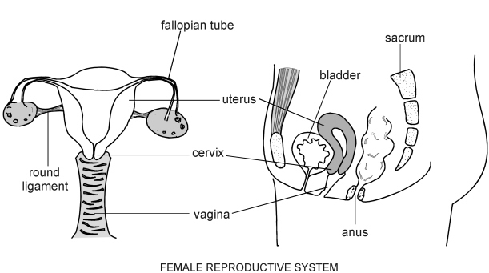  
  
**____OVARIES___-**produce hormones, and eggs  
**Fallopian tubes**-passageway for eggs  
**Uterus**- Where child grows during pregnancy  
**Cervix-**Opening to uterus  
  
**________VAGINA___________**-muscular tube aka: birth canal, where intercourse occurs

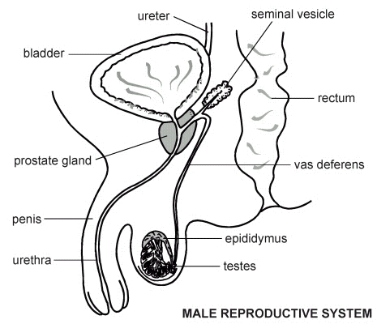

**___TESTES_______ / _____TESTICLES_______**- produce testosterone and sperm

**Epididymis**-sperm storage

**Vas Deferens**-sperm transport

**Seminal Vesicle-**releases fluid that sperm mixes with

**Prostate**-produces more fluid; also common site of cancer in males

**___PENIS____**- “External genitalia”, organ of intercourse

**Urethra**- tube that carries urine and semen out of the body