Nature Scavenger Hunt

Mud Swamp Rd trail, Fox Forest

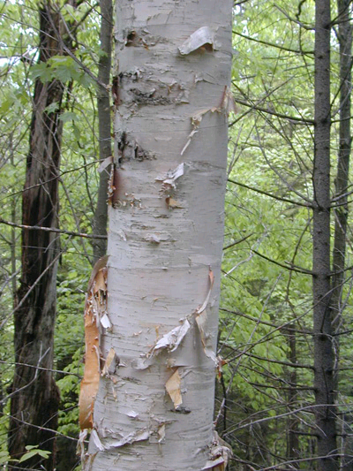

Find:

A tree that looks like this 🡪

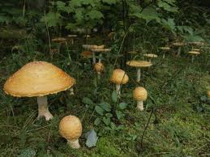

🡨 Any type of mushroom

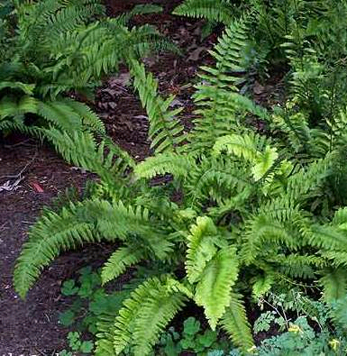

A fern that looks like this🡪

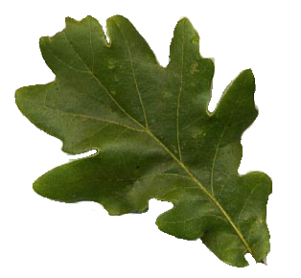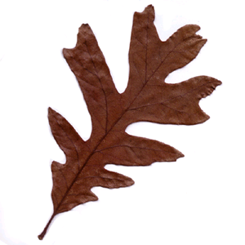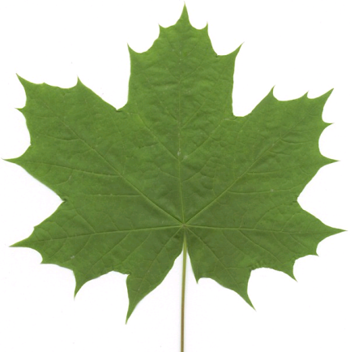

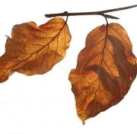

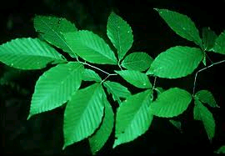

maple leaf oak leaf

beech tree leaf

C:\Documents and Settings\sschlaack\Local Settings\Temporary Internet Files\Content.IE5\OIT8PKXX\MC900383062[1].wmfAny yellow flower Any white flower